Q1.

1.Display the last names of all employees together with the number of years and the number of months they have been employed.

COMMAND: SELECT LAST_NAME<((SYSDATE_HIRE_DATE)/365) NO_OF_YEARS,((SYSDATE-HIRE_DATE)/30 NO_OF_MONTHS FROM EMPLOYEES

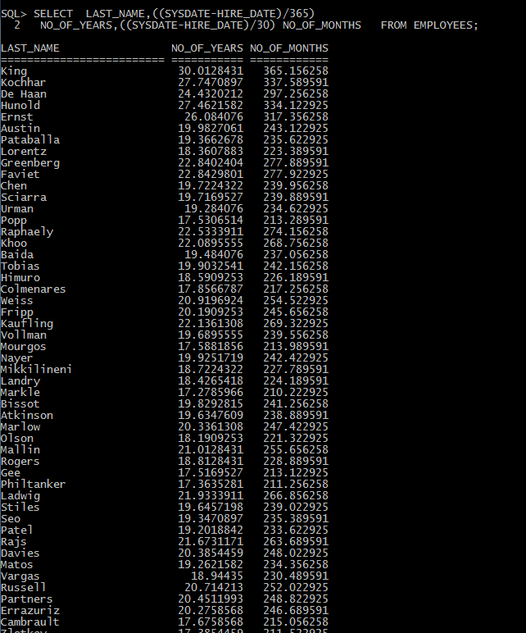

3.Display the first name, last name, hire date and year of joining for all employees.

QUERY:

SELECT FIRST_NAME,LAST_NAME,HIRE_DATE,EXTRACT(YEAR FROM HIRE_DATE) ”YEAR OF JOINING” FROM EMPLOYEES;

OUTPUT:

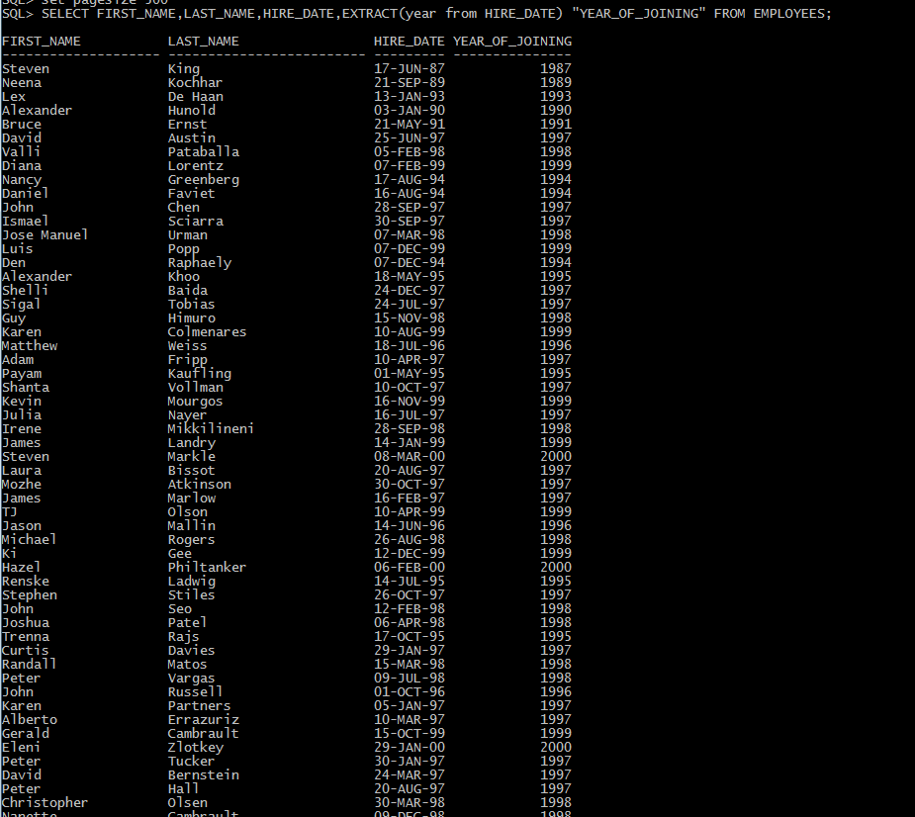

4.Display employee number,last name,hire_date,start-date and salary showing the organization tree under De haan(employee No 102)

QUERY:

SELECT EMPLOYEE_ID,LAST_NAME,HIRE_DATE,SALARY FROM EMPLOYEES CONNECT BY PRIOR EMPLOYEE_ID=MANAGER_ID START WITH EMPLOYEE_ID =102;

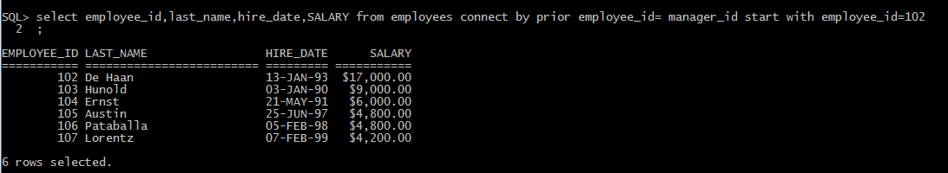

5. Display the employees those have job ids starting with “SA”.

QUERY:

SELECT FIRST_NAME,LAST_NAME,JOB_ID FROM EMPLOYEES WHERE JOB_ID LIKE ‘SA%’;

OUTPUT:  
